Calendar
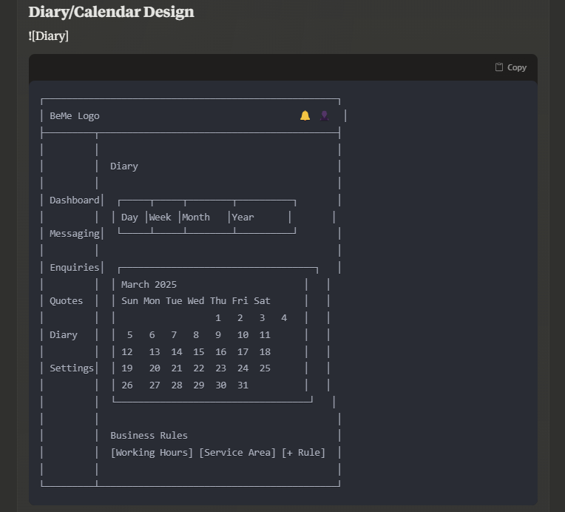

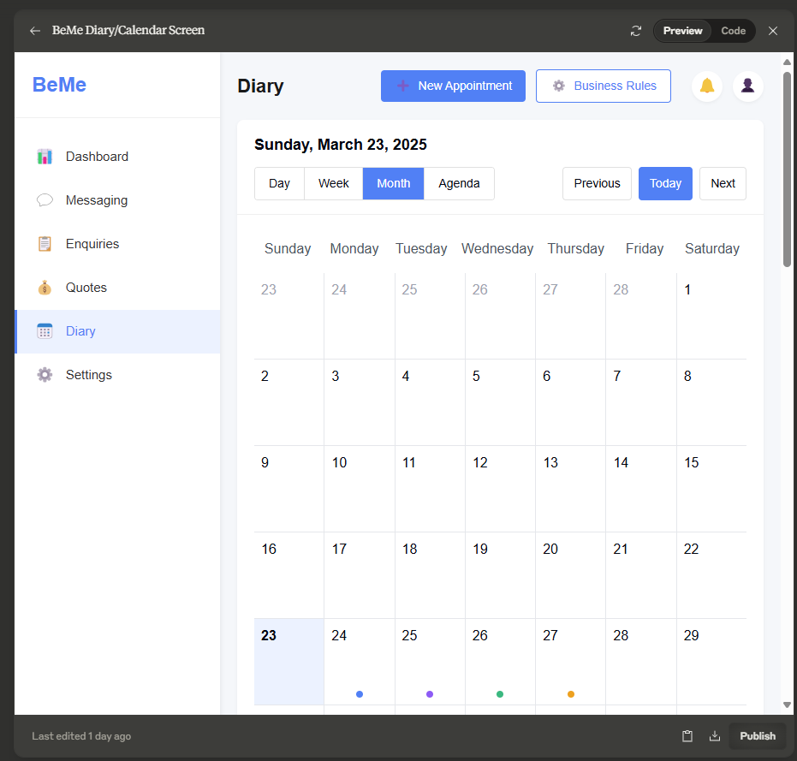

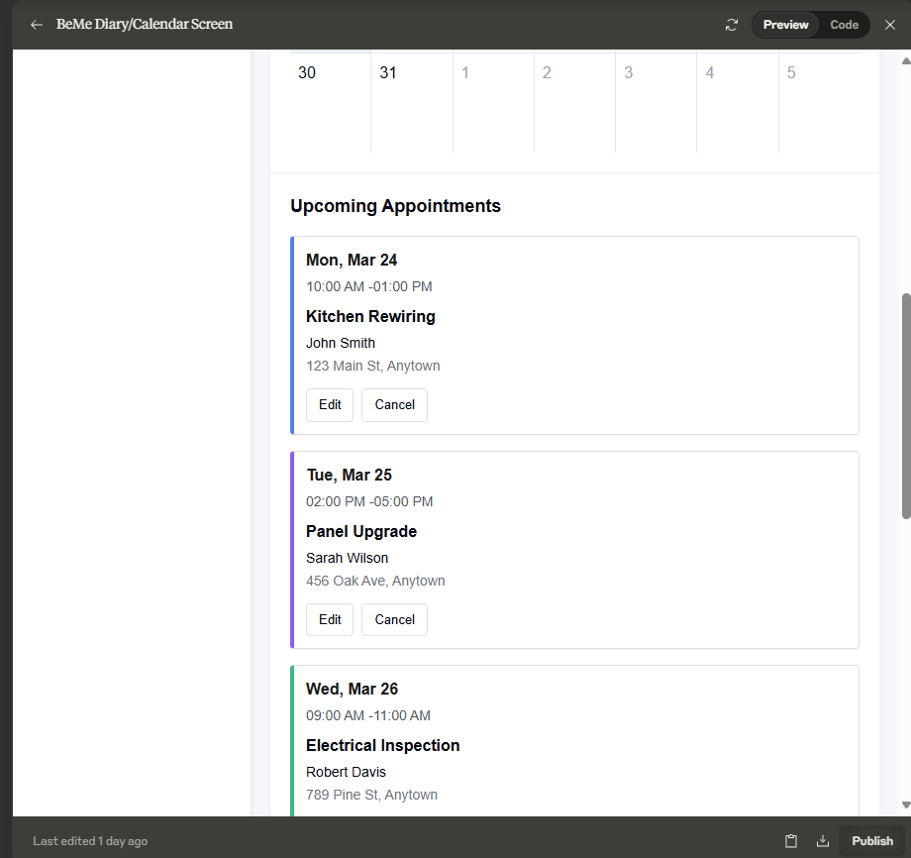
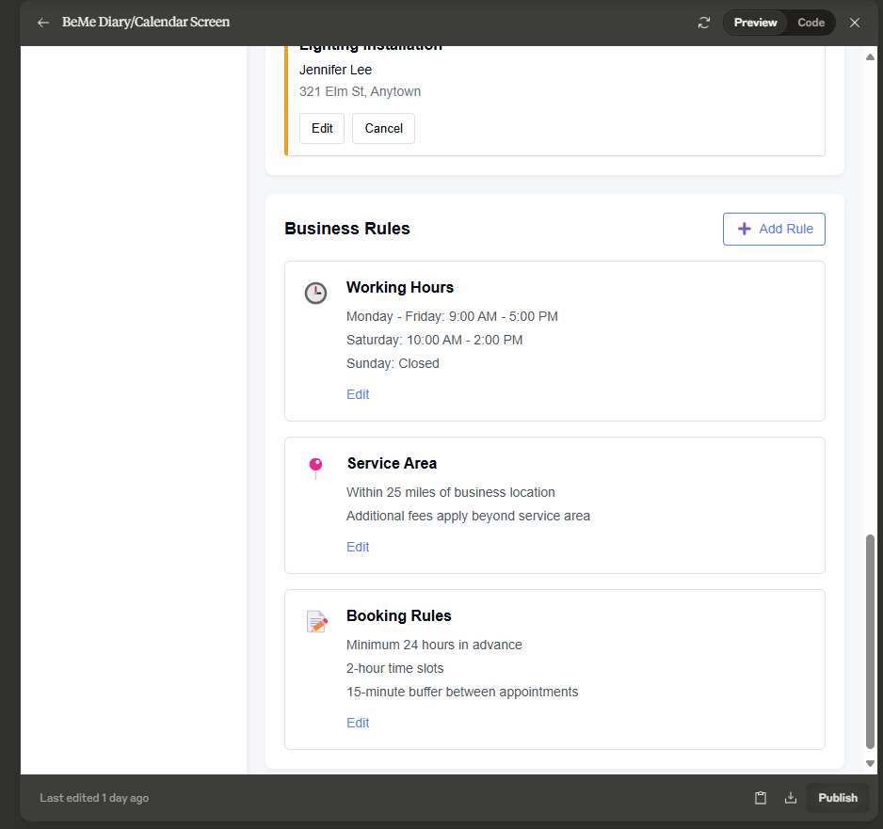

import React, { useState } from 'react';

const Diary = () => {
const [view, setView] = useState('month');
const [currentDate, setCurrentDate] = useState(new Date(2025, 2, 23)); // March 23, 2025

// Sample events data
const events = [
{
id: 1,
title: 'Kitchen Rewiring',
customer: 'John Smith',
address: '123 Main St, Anytown',
start: new Date(2025, 2, 24, 10, 0), // March 24, 2025, 10:00 AM
end: new Date(2025, 2, 24, 13, 0), // March 24, 2025, 1:00 PM
color: '#3B82F6'
},
{
id: 2,
title: 'Panel Upgrade',
customer: 'Sarah Wilson',
address: '456 Oak Ave, Anytown',
start: new Date(2025, 2, 25, 14, 0), // March 25, 2025, 2:00 PM
end: new Date(2025, 2, 25, 17, 0), // March 25, 2025, 5:00 PM
color: '#8B5CF6'
},
{
id: 3,
title: 'Electrical Inspection',
customer: 'Robert Davis',
address: '789 Pine St, Anytown',
start: new Date(2025, 2, 26, 9, 0), // March 26, 2025, 9:00 AM
end: new Date(2025, 2, 26, 11, 0), // March 26, 2025, 11:00 AM
color: '#10B981'
},
{
id: 4,
title: 'Lighting Installation',
customer: 'Jennifer Lee',
address: '321 Elm St, Anytown',
start: new Date(2025, 2, 27, 13, 0), // March 27, 2025, 1:00 PM
end: new Date(2025, 2, 27, 16, 0), // March 27, 2025, 4:00 PM
color: '#F59E0B'
}
];

// Helper function to format date
const formatDate = (date) => {
return date.toLocaleDateString('en-US', {
weekday: 'long',
year: 'numeric',
month: 'long',
day: 'numeric'
});
};

// Business rules data
const businessRules = {
workingHours: {
monday: { start: '09:00', end: '17:00', active: true },
tuesday: { start: '09:00', end: '17:00', active: true },
wednesday: { start: '09:00', end: '17:00', active: true },
thursday: { start: '09:00', end: '17:00', active: true },
friday: { start: '09:00', end: '17:00', active: true },
saturday: { start: '10:00', end: '14:00', active: true },
sunday: { start: '00:00', end: '00:00', active: false }
},
serviceArea: {
radius: 25,
unit: 'miles',
additionalFee: true
}
};

return (
<div className="app-container">
{/* Sidebar */}
<div className="sidebar">
<div className="logo-container">
<div className="logo">BeMe</div>
</div>
<div className="sidebar-menu">
<div className="menu-item">
<div className="menu-icon">📊</div>
<div className="menu-text">Dashboard</div>
</div>
<div className="menu-item">
<div className="menu-icon">💬</div>
<div className="menu-text">Messaging</div>
</div>
<div className="menu-item">
<div className="menu-icon">📋</div>
<div className="menu-text">Enquiries</div>
</div>
<div className="menu-item">
<div className="menu-icon">💰</div>
<div className="menu-text">Quotes</div>
</div>
<div className="menu-item active">
<div className="menu-icon">📅</div>
<div className="menu-text">Diary</div>
</div>
<div className="menu-item">
<div className="menu-icon">⚙️</div>
<div className="menu-text">Settings</div>
</div>
</div>
</div>

{/* Main Content */}
<div className="main-content">
{/* Header */}
<div className="header">
<div className="page-title">Diary</div>
<div className="header-actions">
<button className="new-appointment-btn">
<span className="new-icon">➕</span>
<span>New Appointment</span>
</button>
<button className="rules-btn">
<span className="rules-icon">⚙️</span>
<span>Business Rules</span>
</button>
<div className="notification-icon">🔔</div>
<div className="user-profile">👤</div>
</div>
</div>

{/* Calendar Section */}
<div className="diary-container">
<div className="diary-header">
<div className="current-date">{formatDate(currentDate)}</div>

<div className="view-controls">
<div className="view-selector">
<button className={`view-btn ${view === 'day' ? 'active' : ''}`} onClick={() => setView('day')}>Day</button>
<button className={`view-btn ${view === 'week' ? 'active' : ''}`} onClick={() => setView('week')}>Week</button>
<button className={`view-btn ${view === 'month' ? 'active' : ''}`} onClick={() => setView('month')}>Month</button>
<button className={`view-btn ${view === 'agenda' ? 'active' : ''}`} onClick={() => setView('agenda')}>Agenda</button>
</div>

<div className="date-navigation">
<button className="nav-btn">Previous</button>
<button className="nav-btn today">Today</button>
<button className="nav-btn">Next</button>
</div>
</div>
</div>

<div className="calendar-wrapper">
{/* Month View */}
<div className="month-view">
<div className="month-header">
<div className="day-label">Sunday</div>
<div className="day-label">Monday</div>
<div className="day-label">Tuesday</div>
<div className="day-label">Wednesday</div>
<div className="day-label">Thursday</div>
<div className="day-label">Friday</div>
<div className="day-label">Saturday</div>
</div>

<div className="month-grid">
{/* Week 1 */}
<div className="day-cell prev-month">23</div>
<div className="day-cell prev-month">24</div>
<div className="day-cell prev-month">25</div>
<div className="day-cell prev-month">26</div>
<div className="day-cell prev-month">27</div>
<div className="day-cell prev-month">28</div>
<div className="day-cell">1</div>

{/* Week 2 */}
<div className="day-cell">2</div>
<div className="day-cell">3</div>
<div className="day-cell">4</div>
<div className="day-cell">5</div>
<div className="day-cell">6</div>
<div className="day-cell">7</div>
<div className="day-cell">8</div>

{/* Week 3 */}
<div className="day-cell">9</div>
<div className="day-cell">10</div>
<div className="day-cell">11</div>
<div className="day-cell">12</div>
<div className="day-cell">13</div>
<div className="day-cell">14</div>
<div className="day-cell">15</div>

{/* Week 4 */}
<div className="day-cell">16</div>
<div className="day-cell">17</div>
<div className="day-cell">18</div>
<div className="day-cell">19</div>
<div className="day-cell">20</div>
<div className="day-cell">21</div>
<div className="day-cell">22</div>

{/* Week 5 */}
<div className="day-cell current-day">23</div>
<div className="day-cell has-events">
24
<div className="event-marker" style={{ backgroundColor: '#3B82F6' }}></div>
</div>
<div className="day-cell has-events">
25
<div className="event-marker" style={{ backgroundColor: '#8B5CF6' }}></div>
</div>
<div className="day-cell has-events">
26
<div className="event-marker" style={{ backgroundColor: '#10B981' }}></div>
</div>
<div className="day-cell has-events">
27
<div className="event-marker" style={{ backgroundColor: '#F59E0B' }}></div>
</div>
<div className="day-cell">28</div>
<div className="day-cell">29</div>

{/* Week 6 */}
<div className="day-cell">30</div>
<div className="day-cell">31</div>
<div className="day-cell next-month">1</div>
<div className="day-cell next-month">2</div>
<div className="day-cell next-month">3</div>
<div className="day-cell next-month">4</div>
<div className="day-cell next-month">5</div>
</div>
</div>
</div>

{/* Upcoming Events Section */}
<div className="upcoming-events">
<h2>Upcoming Appointments</h2>
<div className="events-list">
{events.map(event => (
<div key={event.id} className="event-card" style={{ borderLeftColor: event.color }}>
<div className="event-date">
{event.start.toLocaleDateString('en-US', { weekday: 'short', month: 'short', day: 'numeric' })}
</div>
<div className="event-time">
{event.start.toLocaleTimeString('en-US', { hour: '2-digit', minute: '2-digit' })} -
{event.end.toLocaleTimeString('en-US', { hour: '2-digit', minute: '2-digit' })}
</div>
<div className="event-title">{event.title}</div>
<div className="event-customer">{event.customer}</div>
<div className="event-address">{event.address}</div>
<div className="event-actions">
<button className="event-btn">Edit</button>
<button className="event-btn">Cancel</button>
</div>
</div>
))}
</div>
</div>
</div>

{/* Business Rules Section */}
<div className="business-rules">
<div className="section-header">
<h2>Business Rules</h2>
<button className="add-rule-btn">
<span className="add-icon">➕</span>
<span>Add Rule</span>
</button>
</div>

<div className="rules-grid">
{/* Working Hours Rule */}
<div className="rule-card">
<div className="rule-icon">🕒</div>
<div className="rule-content">
<h3>Working Hours</h3>
<div className="rule-details">
<p>Monday - Friday: 9:00 AM - 5:00 PM</p>
<p>Saturday: 10:00 AM - 2:00 PM</p>
<p>Sunday: Closed</p>
</div>
<button className="edit-rule-btn">Edit</button>
</div>
</div>

{/* Service Area Rule */}
<div className="rule-card">
<div className="rule-icon">📍</div>
<div className="rule-content">
<h3>Service Area</h3>
<div className="rule-details">
<p>Within 25 miles of business location</p>
<p>Additional fees apply beyond service area</p>
</div>
<button className="edit-rule-btn">Edit</button>
</div>
</div>

{/* Booking Rule */}
<div className="rule-card">
<div className="rule-icon">📝</div>
<div className="rule-content">
<h3>Booking Rules</h3>
<div className="rule-details">
<p>Minimum 24 hours in advance</p>
<p>2-hour time slots</p>
<p>15-minute buffer between appointments</p>
</div>
<button className="edit-rule-btn">Edit</button>
</div>
</div>
</div>
</div>
</div>

<style jsx>{`
.app-container {
display: flex;
min-height: 100vh;
font-family: 'Inter', sans-serif;
background-color: #f5f7fa;
}

/* Sidebar styles */
.sidebar {
width: 240px;
background-color: white;
box-shadow: 2px 0 4px rgba(0, 0, 0, 0.05);
padding: 20px 0;
display: flex;
flex-direction: column;
}

.logo-container {
padding: 0 20px 20px;
border-bottom: 1px solid #f0f0f0;
margin-bottom: 20px;
}

.logo {
font-size: 24px;
font-weight: bold;
color: #3B82F6;
}

.sidebar-menu {
display: flex;
flex-direction: column;
flex-grow: 1;
}

.menu-item {
display: flex;
align-items: center;
padding: 12px 20px;
cursor: pointer;
transition: background-color 0.2s;
border-left: 3px solid transparent;
}

.menu-item:hover {
background-color: #f5f7fa;
}

.menu-item.active {
background-color: #ebf2ff;
border-left-color: #3B82F6;
}

.menu-icon {
margin-right: 12px;
font-size: 18px;
}

.menu-text {
font-size: 15px;
color: #333;
}

.menu-item.active .menu-text {
font-weight: 500;
color: #3B82F6;
}

/* Main content styles */
.main-content {
flex: 1;
padding: 20px;
overflow-y: auto;
}

.header {
display: flex;
justify-content: space-between;
align-items: center;
margin-bottom: 20px;
}

.page-title {
font-size: 22px;
font-weight: 600;
color: #1a1a1a;
}

.header-actions {
display: flex;
align-items: center;
}

.new-appointment-btn, .rules-btn {
display: flex;
align-items: center;
padding: 8px 16px;
margin-right: 12px;
border-radius: 4px;
font-size: 14px;
font-weight: 500;
cursor: pointer;
transition: background-color 0.2s;
}

.new-appointment-btn {
background-color: #3B82F6;
color: white;
border: none;
}

.new-appointment-btn:hover {
background-color: #2563eb;
}

.rules-btn {
background-color: white;
color: #3B82F6;
border: 1px solid #3B82F6;
}

.rules-btn:hover {
background-color: #ebf2ff;
}

.new-icon, .rules-icon {
margin-right: 8px;
font-size: 14px;
}

.notification-icon, .user-profile {
width: 36px;
height: 36px;
display: flex;
align-items: center;
justify-content: center;
background-color: white;
border-radius: 50%;
margin-left: 12px;
font-size: 18px;
box-shadow: 0 2px 4px rgba(0, 0, 0, 0.05);
cursor: pointer;
}

/* Diary container styles */
.diary-container {
background-color: white;
border-radius: 8px;
box-shadow: 0 2px 4px rgba(0, 0, 0, 0.05);
margin-bottom: 20px;
overflow: hidden;
}

.diary-header {
padding: 16px 20px;
border-bottom: 1px solid #f0f0f0;
}

.current-date {
font-size: 18px;
font-weight: 600;
margin-bottom: 12px;
}

.view-controls {
display: flex;
justify-content: space-between;
align-items: center;
}

.view-selector {
display: flex;
border: 1px solid #e0e0e0;
border-radius: 4px;
overflow: hidden;
}

.view-btn {
padding: 8px 16px;
background-color: white;
border: none;
font-size: 14px;
cursor: pointer;
transition: all 0.2s;
}

.view-btn:not(:last-child) {
border-right: 1px solid #e0e0e0;
}

.view-btn.active {
background-color: #3B82F6;
color: white;
}

.date-navigation {
display: flex;
align-items: center;
}

.nav-btn {
padding: 8px 12px;
background-color: white;
border: 1px solid #e0e0e0;
border-radius: 4px;
font-size: 14px;
cursor: pointer;
transition: all 0.2s;
margin-left: 8px;
}

.nav-btn:hover {
background-color: #f5f7fa;
}

.nav-btn.today {
background-color: #3B82F6;
color: white;
border-color: #3B82F6;
}

.nav-btn.today:hover {
background-color: #2563eb;
}

/* Calendar styles */
.calendar-wrapper {
padding: 20px;
}

.month-header {
display: grid;
grid-template-columns: repeat(7, 1fr);
text-align: center;
font-weight: 500;
color: #4b5563;
margin-bottom: 8px;
}

.day-label {
padding: 8px;
}

.month-grid {
display: grid;
grid-template-columns: repeat(7, 1fr);
grid-template-rows: repeat(6, 100px);
gap: 1px;
background-color: #e5e7eb;
}

.day-cell {
background-color: white;
padding: 8px;
position: relative;
}

.day-cell.prev-month, .day-cell.next-month {
color: #9ca3af;
}

.day-cell.current-day {
background-color: #ebf2ff;
font-weight: 600;
}

.day-cell.has-events {
font-weight: 500;
}

.event-marker {
position: absolute;
bottom: 8px;
left: 50%;
transform: translateX(-50%);
width: 8px;
height: 8px;
border-radius: 50%;
}

/* Upcoming events styles */
.upcoming-events {
padding: 20px;
border-top: 1px solid #f0f0f0;
}

.upcoming-events h2 {
font-size: 18px;
font-weight: 600;
margin: 0 0 16px 0;
}

.events-list {
display: grid;
grid-template-columns: repeat(auto-fill, minmax(300px, 1fr));
gap: 16px;
}

.event-card {
background-color: white;
border: 1px solid #e0e0e0;
border-left: 4px solid #3B82F6;
border-radius: 4px;
padding: 12px;
box-shadow: 0 1px 2px rgba(0, 0, 0, 0.05);
}

.event-date {
font-weight: 600;
color: #1a1a1a;
margin-bottom: 4px;
}

.event-time {
font-size: 14px;
color: #4b5563;
margin-bottom: 8px;
}

.event-title {
font-weight: 600;
margin-bottom: 4px;
}

.event-customer {
font-size: 14px;
margin-bottom: 2px;
}

.event-address {
font-size: 14px;
color: #6b7280;
margin-bottom: 12px;
}

.event-actions {
display: flex;
gap: 8px;
}

.event-btn {
padding: 6px 12px;
background-color: white;
border: 1px solid #e0e0e0;
border-radius: 4px;
font-size: 13px;
cursor: pointer;
transition: all 0.2s;
}

.event-btn:hover {
background-color: #f5f7fa;
}

/* Business rules styles */
.business-rules {
background-color: white;
border-radius: 8px;
box-shadow: 0 2px 4px rgba(0, 0, 0, 0.05);
padding: 20px;
}

.section-header {
display: flex;
justify-content: space-between;
align-items: center;
margin-bottom: 16px;
}

.section-header h2 {
font-size: 18px;
font-weight: 600;
margin: 0;
}

.add-rule-btn {
display: flex;
align-items: center;
padding: 6px 12px;
background-color: white;
color: #3B82F6;
border: 1px solid #3B82F6;
border-radius: 4px;
font-size: 14px;
font-weight: 500;
cursor: pointer;
transition: all 0.2s;
}

.add-rule-btn:hover {
background-color: #ebf2ff;
}

.add-icon {
margin-right: 6px;
font-size: 14px;
}

.rules-grid {
display: grid;
grid-template-columns: repeat(auto-fill, minmax(300px, 1fr));
gap: 16px;
}

.rule-card {
display: flex;
background-color: white;
border: 1px solid #e0e0e0;
border-radius: 6px;
padding: 16px;
transition: all 0.2s;
}

.rule-card:hover {
border-color: #3B82F6;
box-shadow: 0 2px 4px rgba(0, 0, 0, 0.05);
}

.rule-icon {
font-size: 24px;
margin-right: 16px;
}

.rule-content {
flex: 1;
}

.rule-content h3 {
font-size: 16px;
font-weight: 600;
margin: 0 0 8px 0;
}

.rule-details p {
margin: 4px 0;
font-size: 14px;
color: #4b5563;
}

.edit-rule-btn {
margin-top: 8px;
background: none;
border: none;
color: #3B82F6;
font-size: 14px;
cursor: pointer;
padding: 0;
}

.edit-rule-btn:hover {
text-decoration: underline;
}

/* Responsive styles */
@media (max-width: 768px) {
.app-container {
flex-direction: column;
}

.sidebar {
width: 100%;
padding: 12px 0;
}

.header {
flex-direction: column;
align-items: flex-start;
}

.header-actions {
margin-top: 12px;
}

.view-controls {
flex-direction: column;
gap: 12px;
}

.view-selector, .date-navigation {
width: 100%;
}

.month-grid {
grid-template-rows: repeat(6, 80px);
}
}
`}</style>
</div>
);
};

export default Diary;
Last edited 1 day ago

